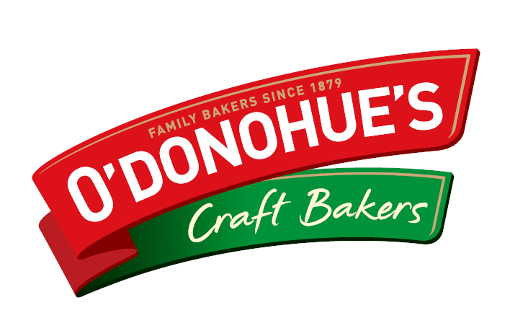

Join us in taking part in Irelands first ever

National Bread Week…

**13th to 18th October 2014**

To win all you need to do is

Make and bake your best wheaten Soda Bread using the recipe below and bring it to the Tasting and Judging which will take place at the Offaly Delicious Food market in the Kilcruttin Centre on

**Saturday 18th October**.

All entries must be registered before 10am

Winner will be announced at 2pm the same day

***Ingredient’s to be used are:***

* 60% Wholemeal or Wheatmeal Flour
* 40% White flour
* Bread soda
* Salt
* Buttermilk

To be made in 7/8 inch (180/200mm) Round Tin or hoop/Ring.

Finished baked soda bread should weigh between

600/700g or 1lb-5ozs to 1lb – 8ozs

Win a Samsung Tab 4

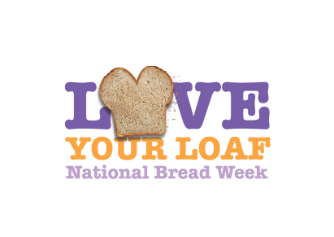

**TERMS AND CONDITIONS**

1. The promoter is: O Donohues Bakery Ltd

2. Employees of O Donohues Bakery Ltd or their family members or anyone else connected in any way with the competition or helping to set up the competition shall not be permitted to enter the competition.

3. There is an entry fee €2 on Saturday 18th October

4. Entry for the competition is open to secondary students only.

5. No responsibility can be accepted for entries not received for whatever reason.

6. All Soda bread will be judged on Saturday 18th October and the winner will receive a brand new **Samsung Tab 4** on the day.

7. No cash alternative to the prizes will be offered. The prizes are not transferable. Prizes are subject to availability and we reserve the right to substitute any prize with another of equivalent value without giving notice.

8. Winner will be chosen on Saturday 18th October at Kilcruttin Business Park where the Offaly Delicious Farmers market takes place off the spollenstown road.

9. The promoter’s decision in respect of all matters to do with the competition will be final and no correspondence will be entered into.

10. By entering this competition, an entrant is indicating his/her agreement to be bound by these terms and conditions.

11. The winner agrees to the use of his/her name and image in any publicity material. Any personal data relating to the winner or any other entrants will be used solely in accordance with current Irish data protection legislation and will not be disclosed to a third party without the entrant’s prior consent

12. The winner may be required to reproduce his/her winning product on the day

13. Entry into the competition will be deemed as acceptance of these terms and conditions.